**SURYA TEJA YATAM**

**Regno : 20A21A05G4**

**Swarnandhra College of Engineering and Technology**

# **BUILDING JAVA RESTAPI USING SPRING BOOT**

STEPS FOR BUILDING RESTAPI USING SPRING BOOT IS GIVEN BELOW:

1.Open the browser and enter the url <https://start.spring.io/> , then spring intializr website will open.

2.Then select the corresponding option such as ,in the project select the maven ,in the language select the java, select the spring boot version as 3.2.0,

and change the meta data as per the your comfort ,select the jar in packaging, and select the corresponding java version in your system ,at the last add the required dependencies in it .

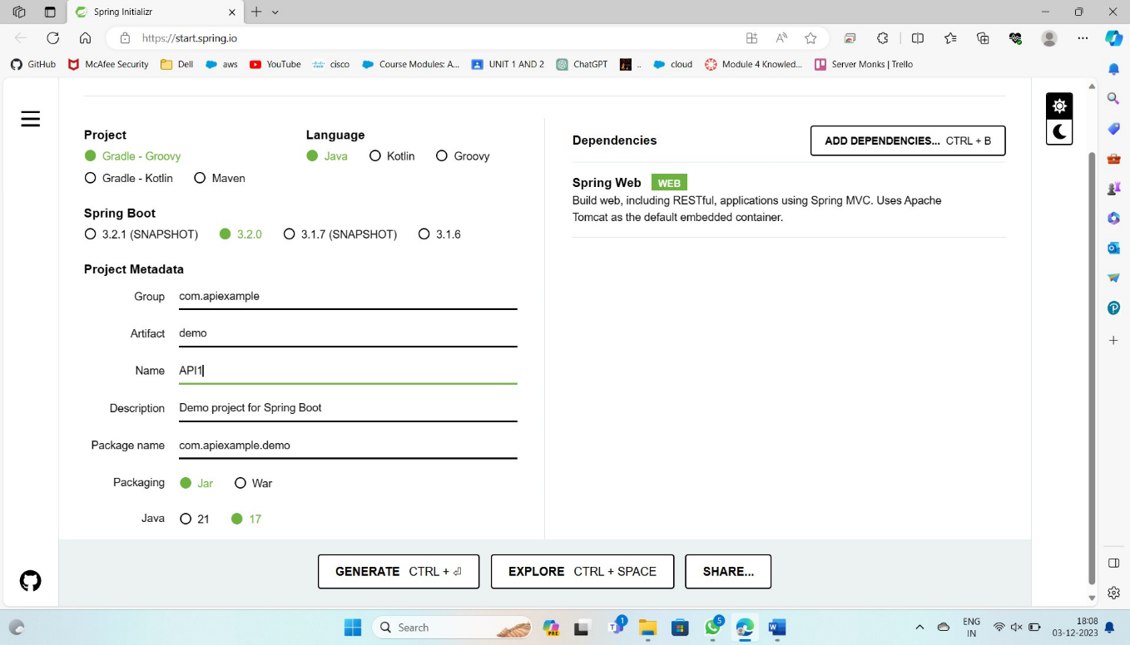

3.After click on the Generate ,then the Zip file is automatically will download and open the downloaded zip file and right click on it . Then tap Extract all and click “**EXTRACT**”.

4.In the extracted file click on the path of search bar and enter “CMD” commad .

5.Then the COMMAND PROMPT app will open automatically , then

type **<<<** code .

6.It directly goes to **VisualStudioCode APP.**

7.Then click on the folder ,in the folder there are sub folders and on one by one SRC > MAIN> JAVA , there will be default application

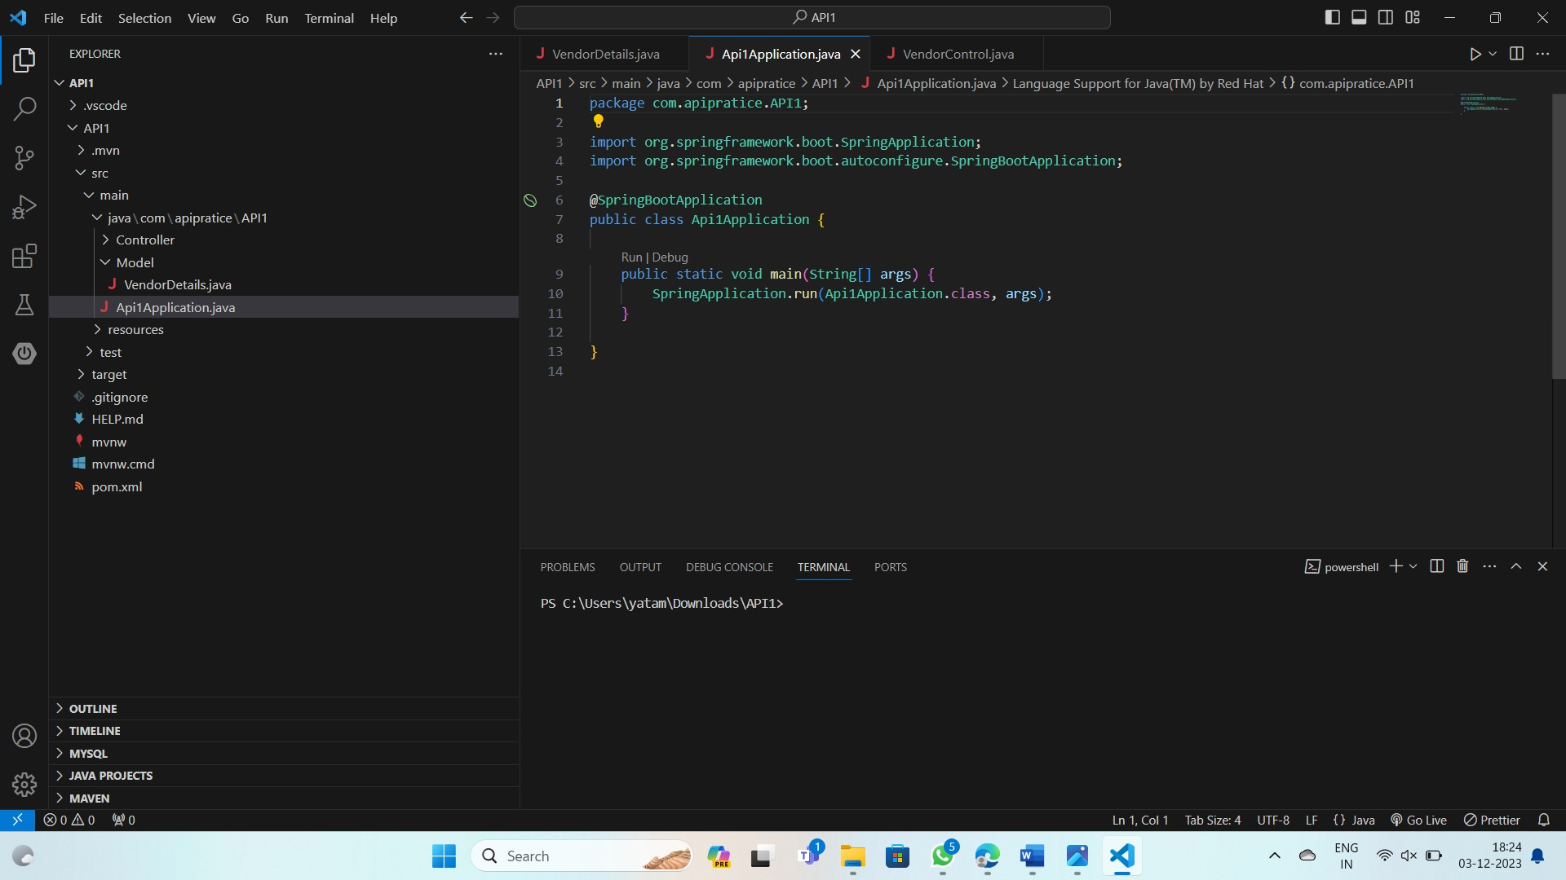

8.Then run the program and “START DEBBUGGING”., if all process done will means then it will shows a TOMCAT webserver started at port **8080.**

9.Then open the browser and search in the url section as localhost:8080, then it returns WhiteLabel Error Page.

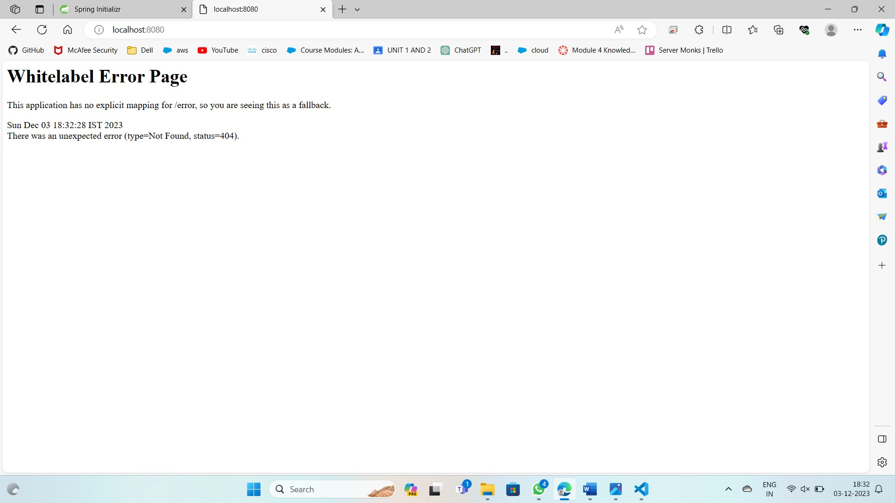

10.In that That API1 sub folder create a new folder named as “Model”, 11. In that folder create a File named as “VendorDetails.java” as shown below…. and enter the code in it.

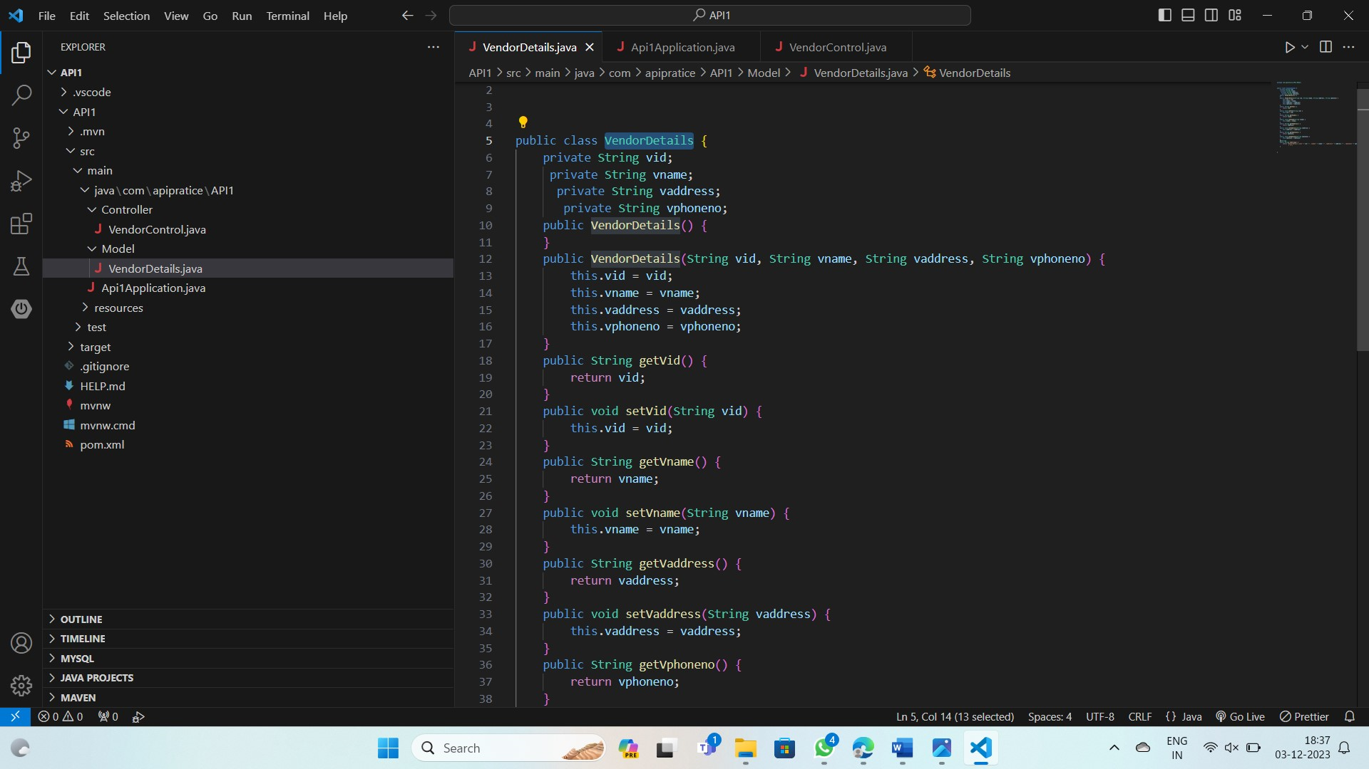

1. And create a another Folder named as “Controller”, in that folder create a file name as VendorControl.java and enter the code in it.

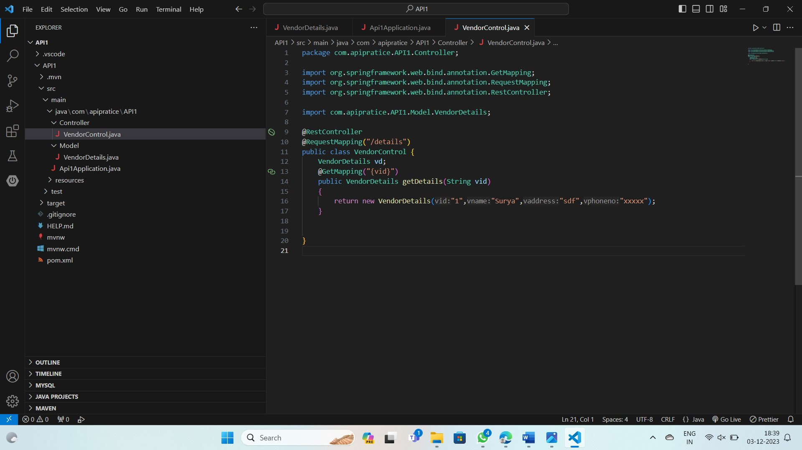

13.After completing the code then click on the RUN and “START DEBBUGGING”. This shows a TOMCAT webserver at port **8080.**

14.Then the web address as localhost:8080/Details/C1

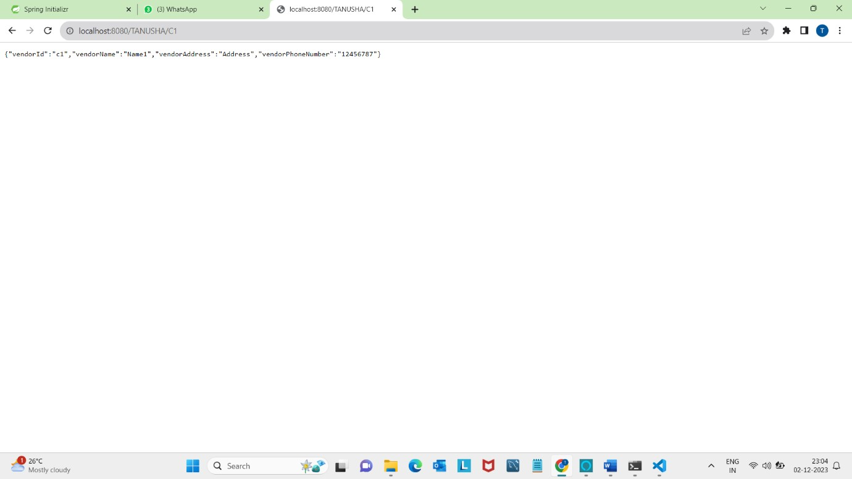 And IT SHOWS THE OUTPUT OF **VENDOR DETAILS**…

# **Performing CRUD Operations in Spring Boot Application**

INSTALL THE POST MAN APPLICTION FOR PERFORMING THE CURD

OPERATION BY USING MYSQL DATABASE

**STEP 1:** Creating the PostMan request in the appilication.

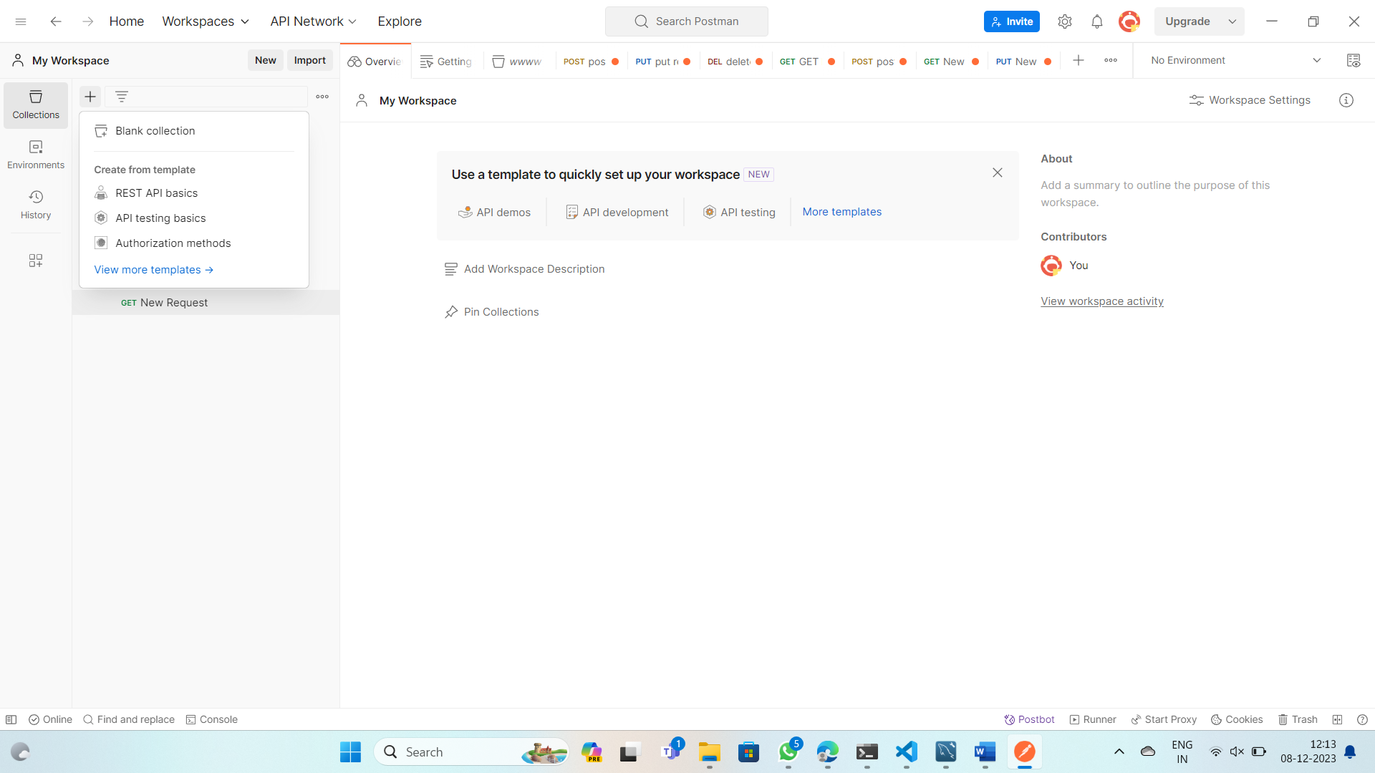

Open postman,Create a request by clicking blank collection

STEP 2: **Performing the Get Operation**

*GET Operation is used to get the details from the DataBase

By clicking the three dots we can create a request and named as GET , and SET the request as GET and enter the url to get the details

Url: https://localhost:8080/VendorDetails/C1.

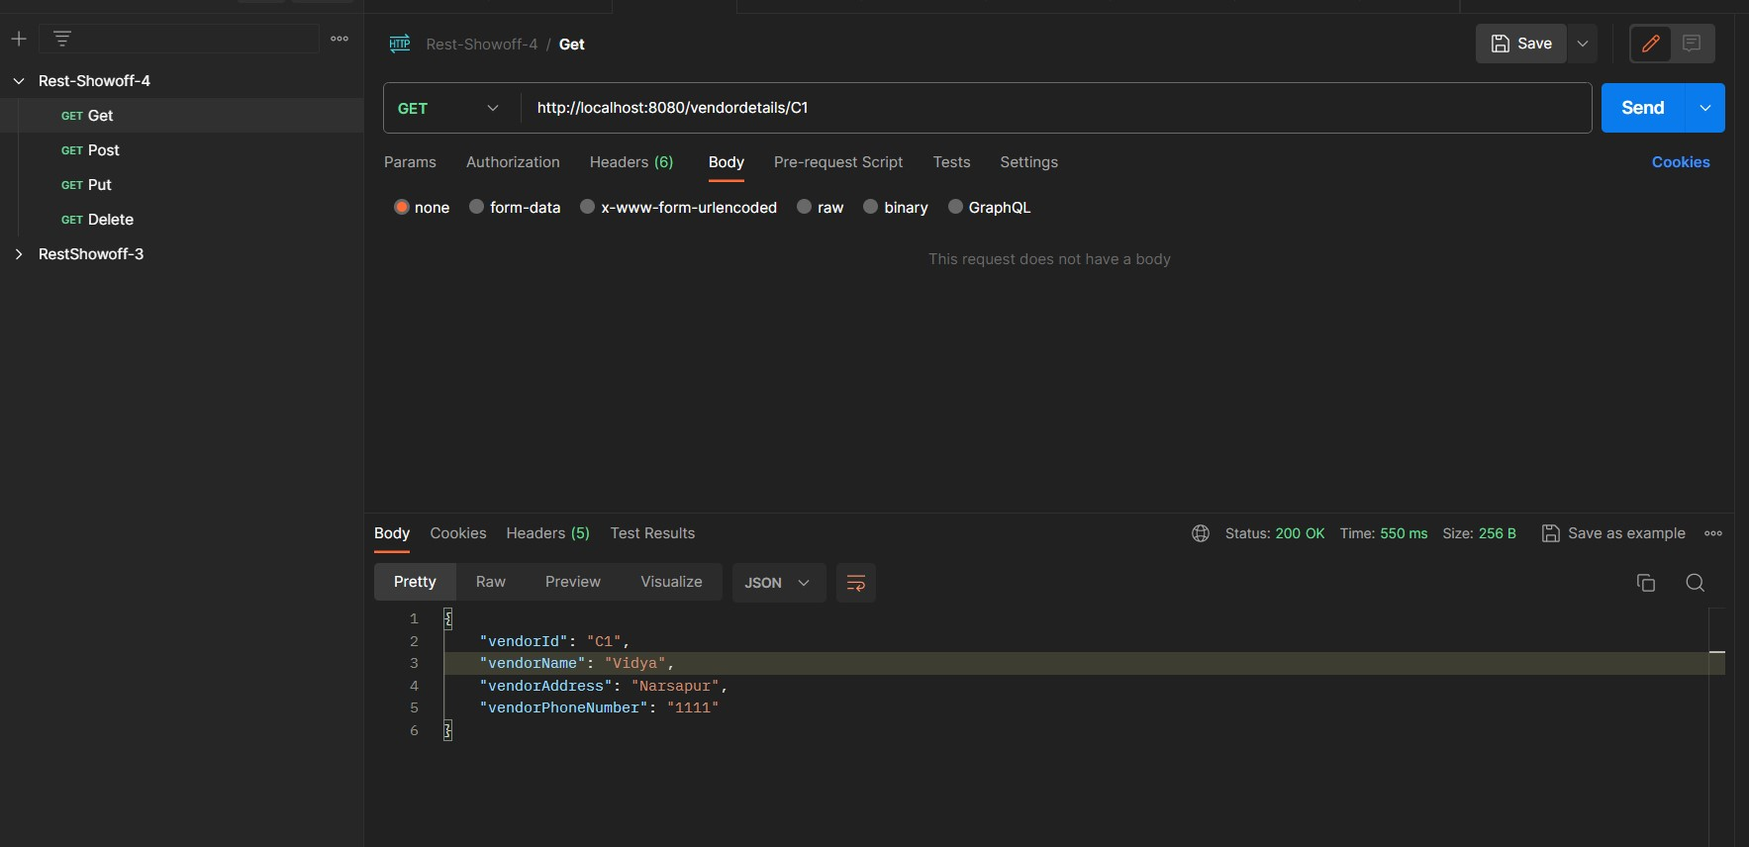

STEP 3: **Performing the Post Operation**

Post operation in spring boot is used to create the information and saved in the database

By clicking the three dots we can create a request and named as POST, and SET the request as POST and enter the url to save the details

Url: <https://localhost:8080/VendorDetails>

Click on the body at the url below and select JSON format to sends the request and enter the details that had to store in the DataBase.

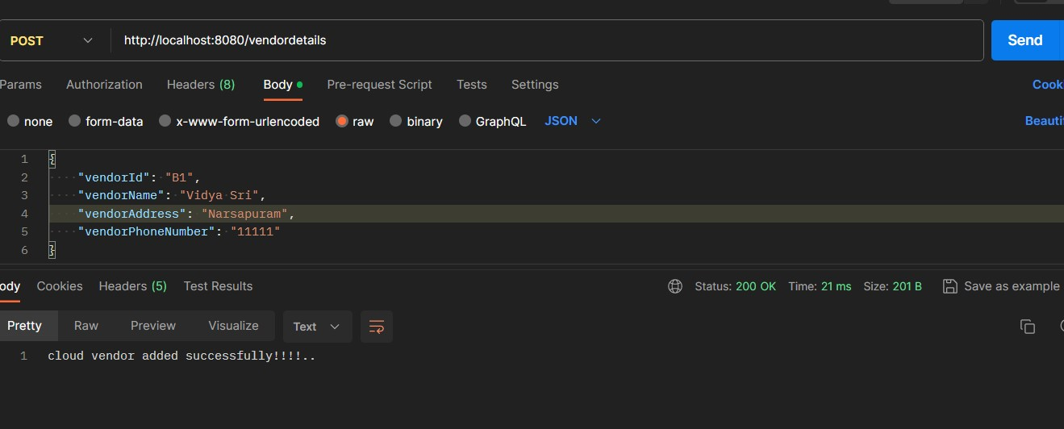

STEP 4: **Performing the Put Operation**

Post operation in spring boot is used to update the information and saved in the database

By clicking the three dots we can create a request and named as PUT, and SET the request as PUT and enter the which contains used to update the information

url : <https://localhost:8080/VendorDetails>

Click on the body at the url below and select JSON format to sends the request and update the details and to store in the DataBase.

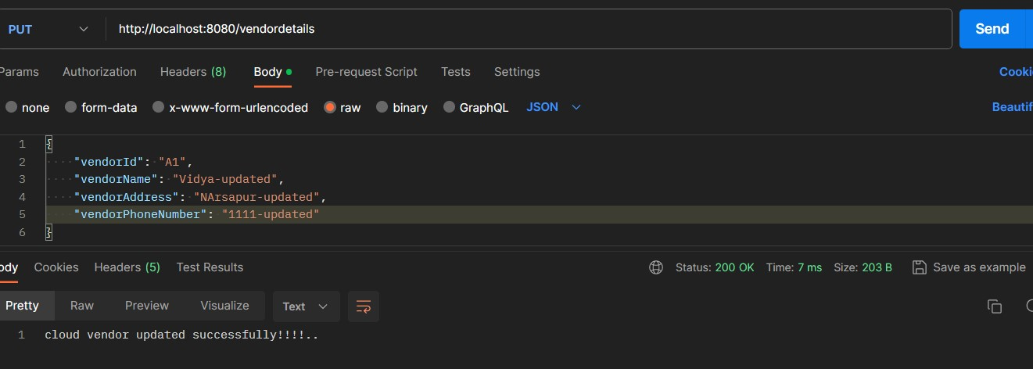

To check the details are updated are not ,perform the GET operation to

recive data from the DataBase.

STEP 5: **Performing the Delete Operation**

Delete operation in spring boot is used to delete the information from the in the database.By entering the id deleting the relavent details in the database.

By clicking the three dots we can create a request and named as DELETE, and SET the request as DELETE and enter the which contains used to delete the information

url : <https://localhost:8080/VendorDetails>

when the id is entered in the url and perform deleting on the corresponding details based on id.

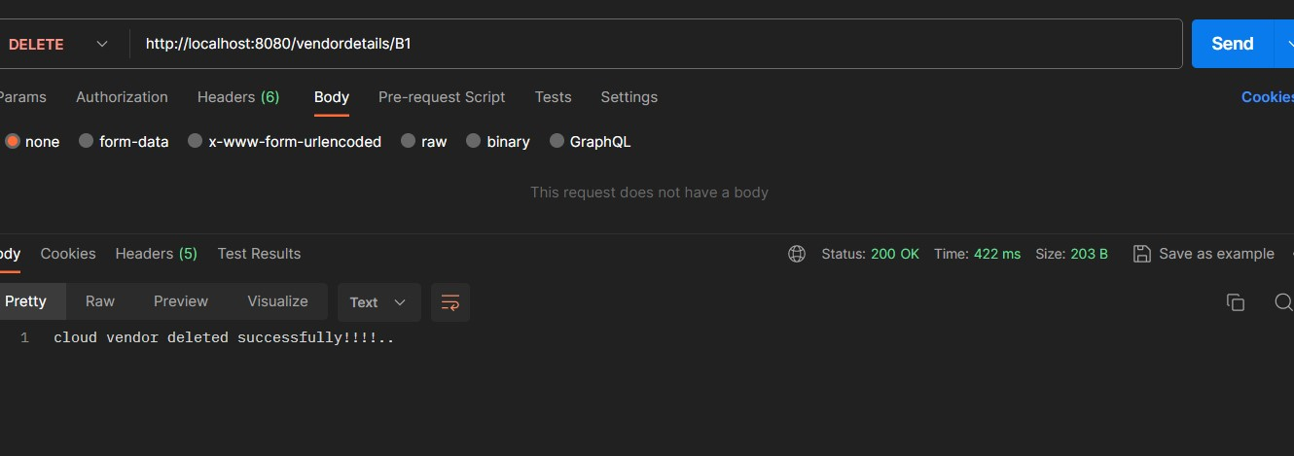

After performing the delete operation we can check the by performing the GET operation .